1. Figure 1: Discontinuity delay



Figure 1: the discontinuity delay of real-time data.

1. Prudent tactic’s resynchronization.

Figure 2 shows how a PT strategy with optimal IB can resynchronize with the actual bus trip. Instead of the expected walking trip (shown as green solid line), the PT optimal user will follow the RTI apps’ pre-calculated optimal plan with insurance buffer (shown as green dash line). Due to the existence of insurance buffer, the reclaimed delay is therefore offset and the user will successfully take the expected bus.



Figure 2: Space-time diagram of a PT trip.

1. Expected waiting time.

For prudent and greedy tactic, the users will plan their home departure time according to the bus’s estimated time of departure, instead of the real departure time. Here we define expected waiting time:

|  |  |  |
| --- | --- | --- |
|  | $$δt^{'}=T_{e}\left(t_{a}\right)-t_{a}=T_{e}\left(t+δt_{w}\right)-t-δt_{w}$$ | (1) |

where: Te(ta) is the estimated time of departure, which depends on , ta is the user’s arrival time at the stop, t is PT strategy’s home departure time, and δtw is the walking time. We can compare equation (1) with the equation (2) in the main text: Te is the

Then, consider the home departure time of prudent tactic in Equation (7) in the main text:

|  |  |  |
| --- | --- | --- |
|  | $$t=t_{c}, if t_{c}+δt_{w}+IB≥T_{e}$$ | (2) |

Therefore:

|  |  |  |
| --- | --- | --- |
|  | $$t+δt_{w}+IB≥T_{e}$$ | (3) |

Combine it with Equation (1) and substitute Te with expected waiting time δt’ plus user’s arrival time at the stop tr:

|  |  |  |
| --- | --- | --- |
|  |  | (4) |

We have: $IB≥δt^{'}$. Therefore, for PT family, insurance buffer should be at least equal to the expected waiting time.

1. The real-time GTFS update frequency for 20 transit systems in the United States.

Table 1 shows the update frequency of all publicly available transit systems in the US that provide GTFS real-time feed from OpenMobilityData.org (OpenMobilityData 2020). We used the GTFS real-time validator (Center for Urban Transportation Research @ USF 2020) to measure the update frequency of each GTFS real-time feed as of May 2020.

|  |  |  |  |
| --- | --- | --- | --- |
| Transit system | Update interval (secs) | Transit system | Update interval (secs) |
| MBTA | ~5 | Go Metro, Cincinnati | ~30 |
| Community transit | ~10 | DCTA, Denton, Texas | ~30 |
| CATA, Lansing, MI | 10 – 20 | VIA, San Antonio | ~30 |
| MST, Monterey, CA | 10 – 20 | HART, Tampa, FL | ~30 |
| RTC, Southern Nevada | 10 – 20 | LTD, [Eugene,](https://openmobilitydata.org/l/225-eugene-or-usa) OR | ~30 |
| Votran, Daytona Beach, FL | 10 – 20 | Metro Transit, Madison, WI | ~30 |
| ART, Arlington, VA | 20 – 30 | MTA Maryland | ~30 |
| Big Blue Bus | 20 – 30 | RTA, riverside, CA | ~30 |
| Calgary Transit | ~30 | Capital metro | ~60 |
| BART | ~30 | CT Transit, Hartford | >60 |

Table 1: GTFS real-time update frequency for 20 transit systems in the United States.

1. Representativeness of the route No.2

We select 6 representative major routes: COTA route 1, 2, 5, 7, 8, and 10. All of these routes have different directions, different and wide spatial and temporal coverage, and large ridership share in the City of Columbus. We select the time period from a typical week from 7/15/2018 – 7/21/2018, when there was no major event like football games and extreme weather.

We reproduce the optimization of prudent tactic for each route. Figure 3 and Figure 4 show the six routes’ prudent tactic optimal’s waiting time. We can see the spatial distribution of the waiting time is highly similar for different routes: the standard service sections (blue part in the service maps to the right) have higher waiting time while the sections with frequent services (red part in the service maps) have lower waiting time. All the maps have same increasing pattern as the walking time (radius of the concentric circles) increases, as we extensively discussed this in the section of walking time impact. This similarity is not limited to the distribution, but also the specific values of the waiting time. Note the maps have same color schemes.

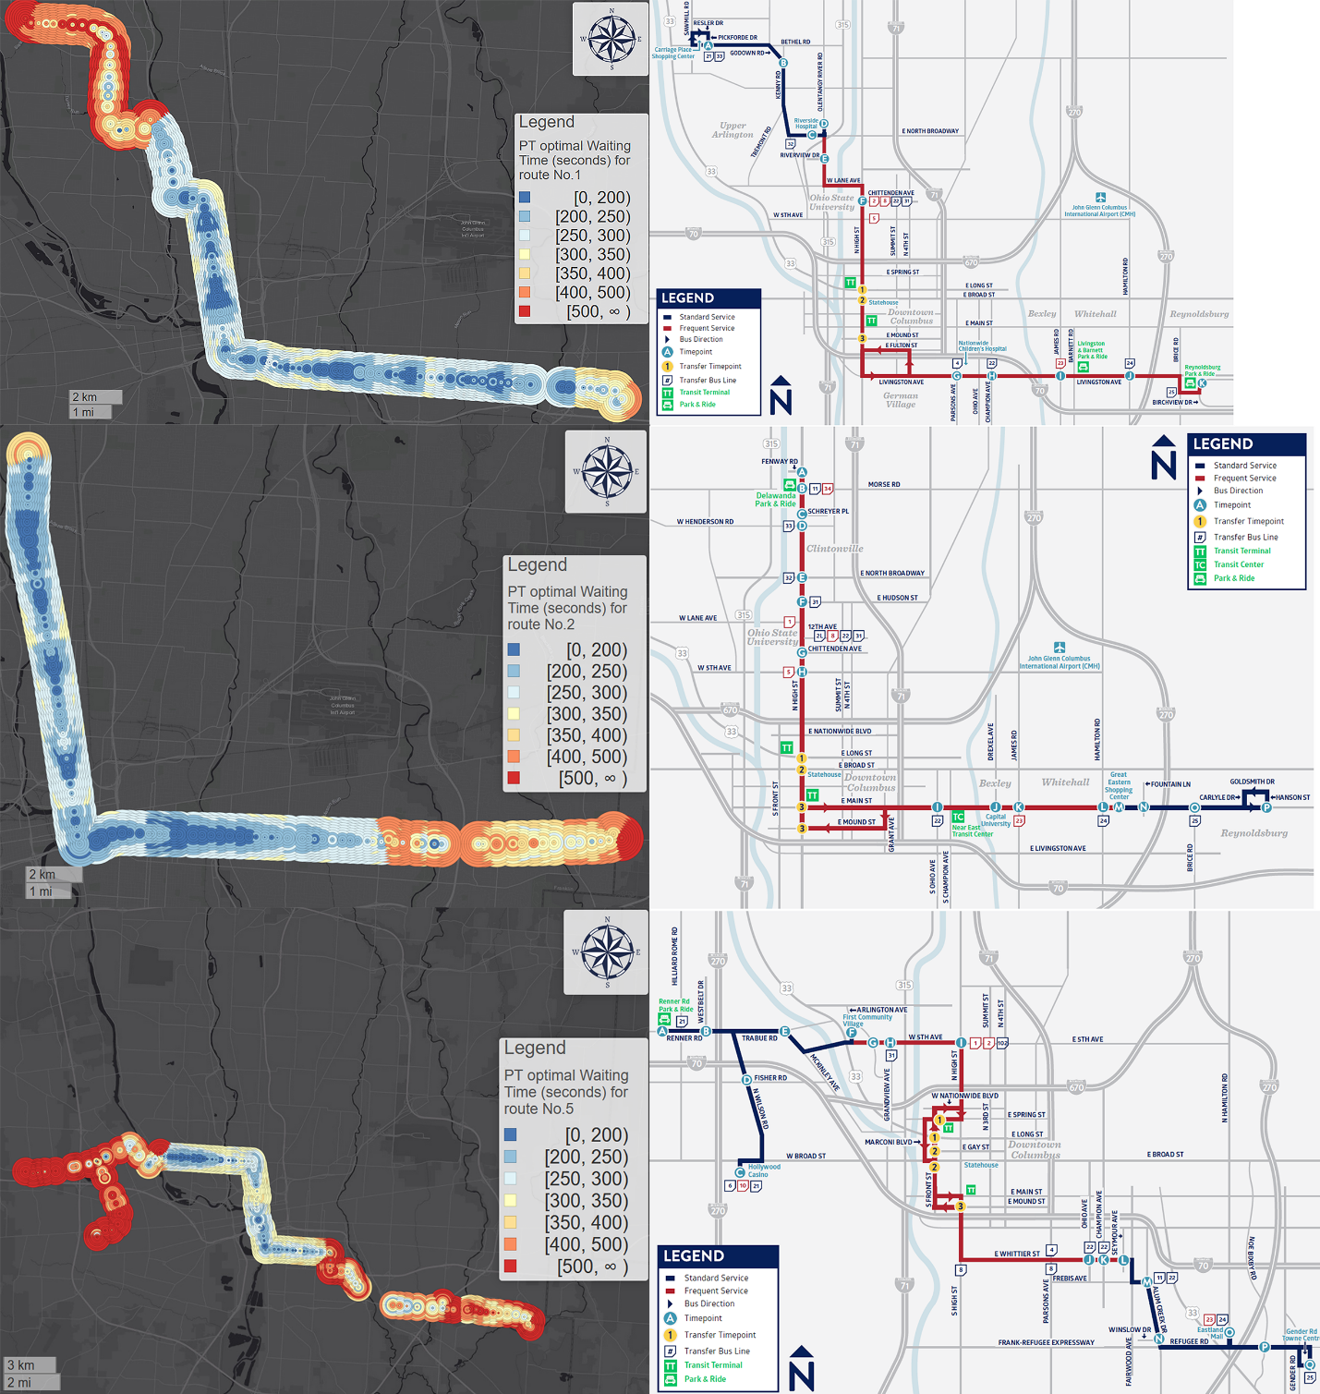

Figure 3: Route 1, 2, and 5's PT optimal's waiting time and route map.

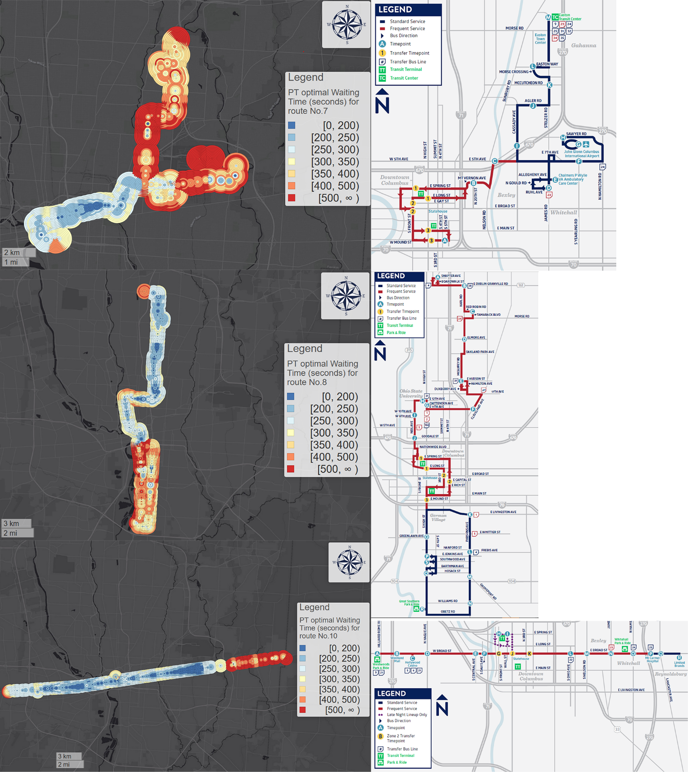

Figure 4: Route 7, 8, and 10's PT optimal's waiting time and route map.